Chronology Chart
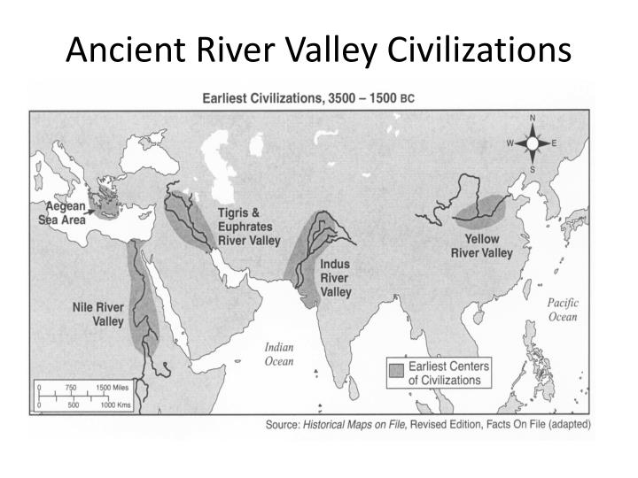

4000 3500 3000 2500 2000 1500 1000 500
Mesopotamia
Egypt
India
China
Hittite
Minoan
Mycenaean

