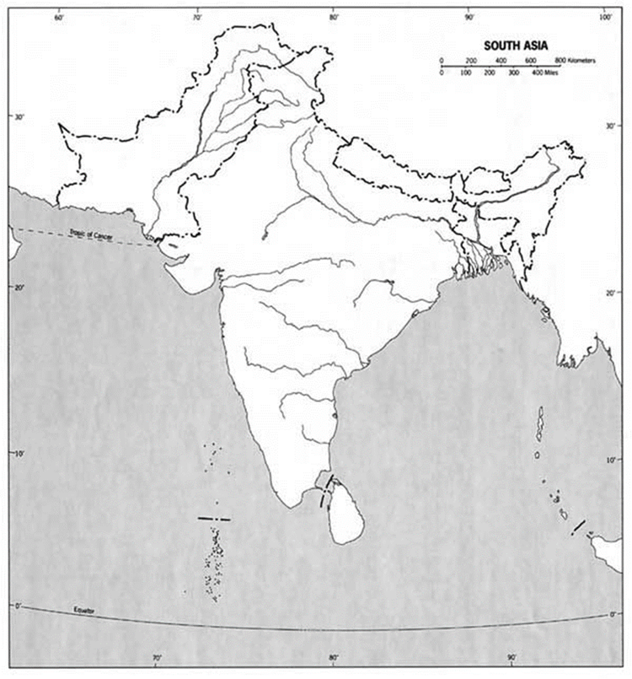

Geographical Places:
Indian Ocean Mount Everest
Arabian Sea Eastern Ghats
Bay of Bengal Western Ghats
Gulf of Kutch Deccan Plateau
Gulf of Khambhat Ganges Plain
Palk Strait Thar Desert
Indus River Sri Lanka
Ganges River Maldives Islands
Brahmaputra River Andaman Islands
Himalayas Narmada River

Countries:
India Pakistan
Bangladesh Nepal
Bhutan

Geographical Terms (Some Review and some New)
Delta Subcontinent
Plateau Elevation
Monsoon Ecosystem
Plate
Cultural hearth

