Ancient Greek World

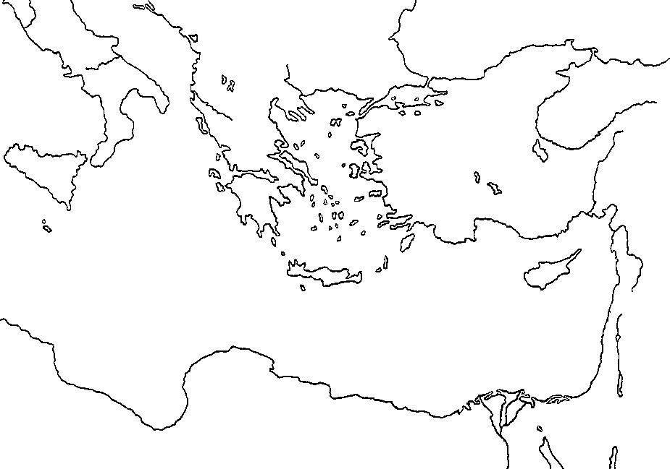

Aegean Sea Hellespont Marathon
Attica Thermopylae Salamis
Athens Sicily
Corinth Alexandria
Sparta Macedonia

